**FOREIGN AFFAIRS MINISTRY**

**UNITED SOCIALIST REPUBLICS**

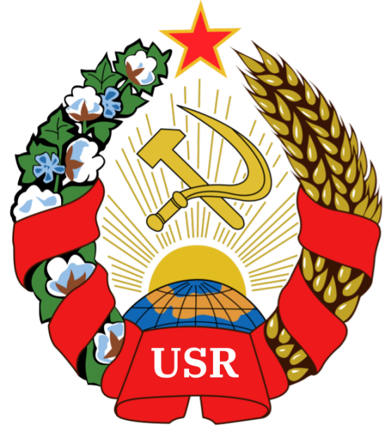

**COMMUNIQUE ON THE AFFAIR OF THE DEATH OF THE QUEEN OF THE UNITED KINGDOM AND COMMONWEALTH REALMS**

**Author:** Comrade GENERAL PRESIDENT TIZIAN ARUNA

**Sponsored by:** The Almendrian AR and the Communist Party of the United Socialist Republics

Hereby releases this document to the public.

We, as citizens of the USR, hereby comndemn

* The progressivism this “Queen” has allowed to take over her country.
* The rise of capitalism within the United Kingdom, thanks in part to this “Queen”
* The rise of (3rd Wave) liberal feminism, Pink Capitalism, Social Democracy, and other degenerate, reactionary systems in the United Kingdom
* The colonialism that this queen continued and enforced during her early years.
* The evil, short-sighted, imperialist takeover of land from Argentina during the Falklands War
* All other capitalist, imperialist conflicts.

We hereby attribute the culpability for these vile acts and many more to Queen Elizabeth, along with the Anglican Church having became [a degenerate shithole](https://external-preview.redd.it/cnh5W4M24Ag6P0wVoJcklYCvTc1oYx-hNj5b3WAwz0A.jpg?auto=webp&s=a901cb0b51e1c237e80bdf05bb75c1d2e486d45b) under her leadership

As such, we hereby celebrate Queen Elizabeth’s death - she was nothing more than a reactionary, capitalist, dictatorial, puppet of the United Nations that works for the New World Order we attempt to prevent

***REST IN PISS, “QUEEN” LIZZIE!***

As such, **it is hereby established,** by decree of the General Presidency, that every September 9th (9/8) shall be the **Day of the Fight agaisnt Degenerate Imperialism and Colonialism**, short being the “Day for the Fight against Imperialism” or “Anti-Imperialism Day”

GLORY TO THE UNITED SOCIALIST REPUBLICS

***WORKERS OF THE WORLD, UNITE!***

*Signed, General President Tizian Aruna.*